SRM INSTITUTE OF SCIENCE AND TECHNOLOGY



18CSC305J - ARTIFICIAL INTELLIGENCE

REPORT SUBMITTED BY -

RAHUL GOEL

RA1911030010094

# LAB 1 – Implementation of toy problems.

**Aim:** Implementation of toy problems

# Problem Statement:

A person has 3000 bananas and a camel. The person wants to transport the maximum number of bananas to a destination which is 1000 KMs away, using only the camel as a mode of transportation. The camel cannot carry more than 1000 bananas at a time and eats a banana every km it travels. What is the maximum number of bananas that can be transferred to the destination using only camel (no other mode of transportation is allowed).

# Code:

banana=int(input('Enter the total number of bananas: ')) dist=int(input('Enter total distance to be covered: '))

ip1 = banana-dist ip2 = banana-ip1 x=(banana-ip1)/5 y=(ip1-ip2)/3 z=ip2-x-y max=ip2-z

print('maximum number of bananas camel can tranfer=',int(max))

# Input:

3000

1000

# Output:Image

**Result**: Hence the toy problem was implemented and the desired output was obtained.

# LAB 2 - Developing agent programs for real world problems

**AIM –** Developing agent programs for real world problems by implementing graph coloring problem

# Problem description:

Graph coloring (also called vertex coloring) is a way of coloring a graph’s vertices such that no two adjacent vertices share the same color. This post will discuss a greedy algorithm for graph coloring and minimize the total number of colors used.

# CODE:

class Graph:

def init (self, edges, n):

self.adjList = [[] for _ in range(n)]

for (src, dest) in edges: self.adjList[src].append(dest) self.adjList[dest].append(src)

def colorGraph(graph, n):

result = {}

for u in range(n):

assigned = set([result.get(i) for i in graph.adjList[u] if i in result]) color = 1

for c in assigned: if color != c: break

color = color + 1 result[u] = color

for v in range(n):

print(f'Color assigned to vertex {v} is {colors[result[v]]}') if name == ' main ':

colors = ['', 'BLUE', 'GREEN', 'RED', 'YELLOW', 'ORANGE', 'PINK', 'BLACK', 'BROWN', 'WHITE', 'PURPLE', 'VOILET']

edges = [(0, 1), (0, 4), (0, 5), (4, 5), (1, 4), (1, 3), (2, 3), (2, 4)]

n = 8

graph = Graph(edges, n) colorGraph(graph, n)

# OUTPUT:

Color assigned to vertex 0 is BLUE Color assigned to vertex 1 is GREEN Color assigned to vertex 2 is BLUE Color assigned to vertex 3 is RED Color assigned to vertex 4 is RED Color assigned to vertex 5 is GREEN Color assigned to vertex 6 is BLUE Color assigned to vertex 7 is BLUE

# SCREENSHOTS:Image

# image4.jpeg

## **RESULT:** Hence, Developing agent programs for real world problems was implemented using graph coloring problem.

**LAB 3 - Constrain Satisfaction Problem**

**AIM:** To implement Constraint satisfaction problem using python.

# Problem Description:

In a CSP, we have a set of variables with known domains and a set of constraints that impose restrictions on the values those variables can take. Our task is to assign a value to each variable so that we fulfil all the constraints.

So, to formally define a CSP, we specify:

* the set of variables
* the set of their (finite or infinite) domains
* and the set of constraints , where each can involve any number of variables:

**CODE:**

import itertools

def get_value(word, substitution): s = 0 factor =

1 for letter in reversed(word):

s += factor * substitution[letter] factor *= 10

return s

def solve2(equation):

left, right = equation.lower().replace(' ', '').split('=') left = left.split('+') letters = set(right) for word in left: for letter in word: letters.add(letter)

letters = list(letters)

digits = range(10) for perm in itertools.permutations(digits, len(letters)):

sol = dict(zip(letters, perm))

if sum(get_value(word, sol) for word in left) == get_value(right, sol): print(' + '.join(str(get_value(word, sol)) for word in left) + " = {} (mapping: {})".format(get_value(right, sol), sol))

print('SEND + MORE = MONEY ') solve2('SEND + MORE = MONEY ')

# OUTPUT:

SEND + MORE = MONEY

2817 + 368 = 3185 (mapping: {'s': 2, 'n': 1, 'r': 6, 'e': 8, 'o': 3, 'd': 7, 'y': 5, 'm': 0})

2819 + 368 = 3187 (mapping: {'s': 2, 'n': 1, 'r': 6, 'e': 8, 'o': 3, 'd': 9, 'y': 7, 'm': 0})

3719 + 457 = 4176 (mapping: {'s': 3, 'n': 1, 'r': 5, 'e': 7, 'o': 4, 'd': 9, 'y': 6, 'm': 0})

3712 + 467 = 4179 (mapping: {'s': 3, 'n': 1, 'r': 6, 'e': 7, 'o': 4, 'd': 2, 'y': 9, 'm': 0})

3829 + 458 = 4287 (mapping: {'s': 3, 'n': 2, 'r': 5, 'e': 8, 'o': 4, 'd': 9, 'y': 7, 'm': 0})

3821 + 468 = 4289 (mapping: {'s': 3, 'n': 2, 'r': 6, 'e': 8, 'o': 4, 'd': 1, 'y': 9, 'm': 0})

5731 + 647 = 6378 (mapping: {'s': 5, 'n': 3, 'r': 4, 'e': 7, 'o': 6, 'd': 1, 'y': 8, 'm': 0})

5732 + 647 = 6379 (mapping: {'s': 5, 'n': 3, 'r': 4, 'e': 7, 'o': 6, 'd': 2, 'y': 9, 'm': 0})

5849 + 638 = 6487 (mapping: {'s': 5, 'n': 4, 'r': 3, 'e': 8, 'o': 6, 'd': 9, 'y': 7, 'm': 0})

6419 + 724 = 7143 (mapping: {'s': 6, 'n': 1, 'r': 2, 'e': 4, 'o': 7, 'd': 9, 'y': 3, 'm': 0})

6415 + 734 = 7149 (mapping: {'s': 6, 'n': 1, 'r': 3, 'e': 4, 'o': 7, 'd': 5, 'y': 9, 'm': 0})

6524 + 735 = 7259 (mapping: {'s': 6, 'n': 2, 'r': 3, 'e': 5, 'o': 7, 'd': 4, 'y': 9, 'm': 0})

6853 + 728 = 7581 (mapping: {'s': 6, 'n': 5, 'r': 2, 'e': 8, 'o': 7, 'd': 3, 'y': 1, 'm': 0})

6851 + 738 = 7589 (mapping: {'s': 6, 'n': 5, 'r': 3, 'e': 8, 'o': 7, 'd': 1, 'y': 9, 'm': 0})

7316 + 823 = 8139 (mapping: {'s': 7, 'n': 1, 'r': 2, 'e': 3, 'o': 8, 'd': 6, 'y': 9, 'm': 0})

7429 + 814 = 8243 (mapping: {'s': 7, 'n': 2, 'r': 1, 'e': 4, 'o': 8, 'd': 9, 'y': 3, 'm': 0})

7539 + 815 = 8354 (mapping: {'s': 7, 'n': 3, 'r': 1, 'e': 5, 'o': 8, 'd': 9, 'y': 4, 'm': 0})

7531 + 825 = 8356 (mapping: {'s': 7, 'n': 3, 'r': 2, 'e': 5, 'o': 8, 'd': 1, 'y': 6, 'm': 0})

7534 + 825 = 8359 (mapping: {'s': 7, 'n': 3, 'r': 2, 'e': 5, 'o': 8, 'd': 4, 'y': 9, 'm': 0})

7649 + 816 = 8465 (mapping: {'s': 7, 'n': 4, 'r': 1, 'e': 6, 'o': 8, 'd': 9, 'y': 5, 'm': 0})

7643 + 826 = 8469 (mapping: {'s': 7, 'n': 4, 'r': 2, 'e': 6, 'o': 8, 'd': 3, 'y': 9, 'm': 0})

8324 + 913 = 9237 (mapping: {'s': 8, 'n': 2, 'r': 1, 'e': 3, 'o': 9, 'd': 4, 'y': 7, 'm': 0})

8432 + 914 = 9346 (mapping: {'s': 8, 'n': 3, 'r': 1, 'e': 4, 'o': 9, 'd': 2, 'y': 6, 'm': 0})

8542 + 915 = 9457 (mapping: {'s': 8, 'n': 4, 'r': 1, 'e': 5, 'o': 9, 'd': 2, 'y': 7, 'm': 0})

9567 + 1085 = 10652 (mapping: {'s': 9, 'n': 6, 'r': 8, 'e': 5, 'o': 0, 'd': 7, 'y': 2, 'm': 1})

# SCREENSHOTS:Image

**Results:**

Constraint Satisfaction problem has been successfully implemented.

# LAB 4- Implementation and Analysis of BFS and DFS for an application

**AIM –** Implementation and analysis of BFS and DFS for an application.

# Problem Description of BFS:

Breadth-first search (BFS) is an algorithm for searching a tree data structure for a node that satisfies a given property. It starts at the tree root and explores all nodes at the present depth prior to moving on to the nodes at the next depth level. Extra memory, usually a queue, is needed to keep track of the child nodes that were encountered but not yet explored.

# BFS Breadth First Search Code:

graph = { '5' : ['3','7'],

'3' : ['2', '4'],

'7' : ['8'],

'2' : [],

'4' : ['8'],

'8' : [] } visited = [] queue = [] def bfs(visited, graph, node): visited.append(node)

queue.append(node) while queue: m = queue.pop(0) print (m, end = " ") for neighbour in graph[m]:

if neighbour not in visited: visited.append(neighbour) queue.append(neighbour)

print("Following is the Breadth-First Search") bfs(visited, graph, '5')

# Screenshot:Image

**Problem Description of DFS:**

Depth First Search (DFS) is often used for traversing and searching a tree or graph data structure. The idea is to start at the root (in the case of a tree) or some arbitrary node (in the case of a graph) and explores each branch as far as possible before backtracking.

# DFS – Depth First Search Code:

graph = {

'A' : ['B','C'],

'B' : ['D'],

'C' : ['F'],

'D' : ['E', 'F'], 'E' : [],

'F' : ['A']

}

visited = set() # Keep track of visited nodes.

def dfs(visited, graph, node): if node not in visited:

print (node) visited.add(node) for neighbour in graph[node]: dfs(visited, graph, neighbour)

dfs(visited, graph, 'A')

# Screenshot:

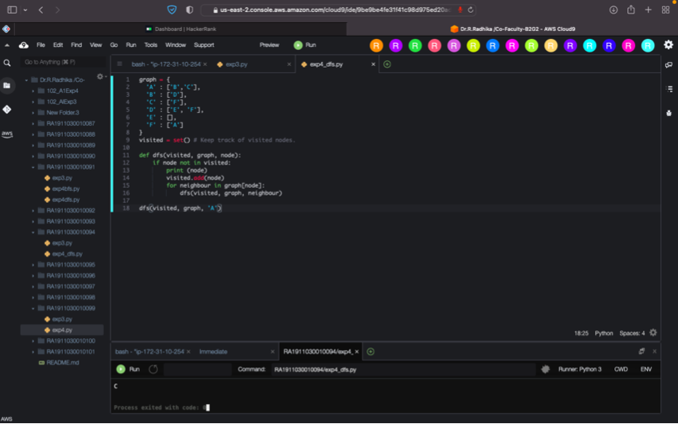

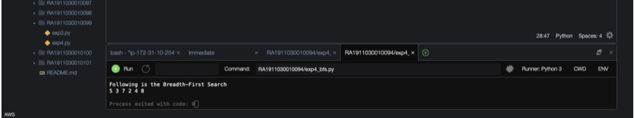

**RESULT:** Hence, BFS and DFS was implemented and analysed for an application.

# LAB 5 – Developing Best First Search and A* Algorithm for real world problem

**AIM:** Implementation of Best First Search for an application

# Problem Description for BFS:

Best first search is a traversal technique that decides which node is to be visited next by checking which node is the most promising one and then check it For this it uses an evaluation function to decide the traversal. This best first search technique of tree traversal comes under the category of heuristic search or informed search technique**.**

# CODE:

from queue import PriorityQueue v = 14

graph = [[] for i in range(v)]

def best_first_search(source, target, n): visited = [0] * n

visited[0] = True pq = PriorityQueue() pq.put((0, source)) while pq.empty() == False:

u = pq.get()[1]

print(u, end=" ") if u == target:

break

for v, c in graph[u]: if visited[v] == False: visited[v] = True pq.put((c, v)) print()

def addedge(x, y, cost): graph[x].append((y, cost))

graph[y].append((x, cost))

addedge(0, 1, 3)

addedge(0, 2, 6)

addedge(0, 3, 5)

addedge(1, 4, 9)

addedge(1, 5, 8)

addedge(2, 6, 12)

addedge(2, 7, 14)

addedge(3, 8, 7)

addedge(8, 9, 5)

addedge(8, 10, 6)

addedge(9, 11, 1)

addedge(9, 12, 10)

addedge(9, 13, 2)

source = 0

target = 9 best_first_search(source, target, v)

# OUTPUT

0 1 3 2 8 9

# SCREENSHOT:

# Image

**A* algorithm:**

* open set is list of nodes which have been visited but neighbors haven’t all been inspected whereas closed set is list of nodes which have been visited but neighbors have been inspected.
* g contains current distances from start node to all other nodes.
* parents contains adjacency map of all nodes
* we find a node with the lowest value of f() - evaluation function
* if the current node is the stop_node then we begin reconstructing the path from it to the start_node
* if the current node isn’t in both open set and closed set add it to open set and note n as its parent
* otherwise, check if it&#39;s quicker to first visit n, then m and if it is, update parent data and g data and if the node was in the closed set, move it to open set
* remove n from the open set, and add it to closed set because all of his neighbors were inspected

# GRAPH:

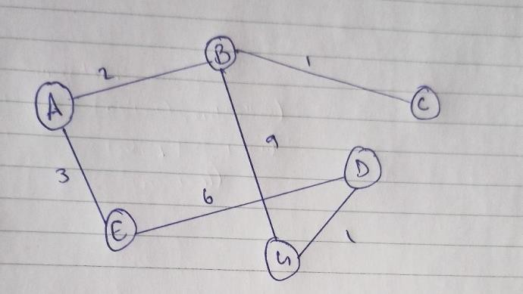

**CODE:**

def aStarAlgo(start_node, stop_node): open_set = set(start_node)

closed_set = set() g = {}

parents = {} g[start_node] = 0

parents[start_node] = start_node while len(open_set) > 0:

n = None

for v in open_set:

if n == None or g[v] + heuristic(v) < g[n] + heuristic(n):

n = v

if n == stop_node or Graph_nodes[n] == None: pass

else:

for (m, weight) in get_neighbors(n):

if m not in open_set and m not in closed_set: open_set.add(m)

parents[m] = n

g[m] = g[n] + weight else:

if g[m] > g[n] + weight:

g[m] = g[n] + weight parents[m] = n

if m in closed_set: closed_set.remove(m) open_set.add(m)

if n == None:

print('Path does not exist!') return None

if n == stop_node:

path = []

while parents[n] != n: path.append(n)

n = parents[n] path.append(start_node) path.reverse()

print('Path found: {}'.format(path)) return path

open_set.remove(n) closed_set.add(n) print('Path does not exist!') return None

def get_neighbors(v): if v in Graph_nodes: return Graph_nodes[v] else:

return None def heuristic(n): H_dist = {

'A': 11,

'B': 6,

'C': 99,

'D': 1,

'E': 7,

'G': 0,

}

return H_dist[n] Graph_nodes = { 'A': [('B', 2), ('E', 3)],

'B': [('C', 1),('G', 9)],

'C': None, 'E': [('D', 6)],

'D': [('G', 1)],

}

aStarAlgo('A', 'G')

# OUTPUT:Image

**Result:** Therefore, BFS and A* algorithm has been implemented successfully

**LAB 6 - Minimax algorithm for an application AIM:** Implementation of minimax algorithm for Tic Tac Toe.

# Problem Description:

* If the game is over, return the score from X's perspective.
* Otherwise get a list of new game states for every possible move
* Create a scores list
* For each of these states add the minimax result of that state to the scores list
* If it's X's turn, return the maximum score from the scores list
* If it's O's turn, return the minimum score from the scores list

# CODE:

theBoard = {'1': ' ' , '2': ' ' , '3': ' ' ,

'4': ' ' , '5': ' ' , '6': ' ' ,

'7': ' ' , '8': ' ' , '9': ' ' }

board_keys = [] for key in theBoard:

board_keys.append(key) def printBoard(board):

print(board['7'] + '|' + board['8'] + '|' + board['9']) print(' ')

print(board['4'] + '|' + board['5'] + '|' + board['6']) print(' ')

print(board['1'] + '|' + board['2'] + '|' + board['3']) def game(): turn = 'X' count = 0 for i in range(10):

printBoard(theBoard)

print("It's your turn " + turn + ". Move to which place?") move = input()

if theBoard[move] == ' ': theBoard[move] = turn

count += 1

else:

print("That place is already filled.\n Move to which place?")

continue

if count >= 5: if theBoard['7'] == theBoard['8'] == theBoard['9'] != ' ':

printBoard(theBoard)

print("\nGame Over.\n")

print(" ** " +turn + " won. **") break elif theBoard['4'] == theBoard['5'] == theBoard['6'] != ' ':

printBoard(theBoard) print("\nGame Over.\n")

print(" ** " +turn + " won. **") break elif theBoard['1'] == theBoard['2'] == theBoard['3'] != ' ':

printBoard(theBoard) print("\nGame Over.\n") print(" ** " +turn + " won. **")

break elif theBoard['1'] == theBoard['4']

== theBoard['7'] != ' ':

printBoard(theBoard) print("\nGame Over.\n") print(" ** " +turn + " won. **")

break elif theBoard['2'] == theBoard['5']

== theBoard['8'] != ' ':

printBoard(theBoard) print("\nGame Over.\n") print(" ** " +turn + " won. **")

break elif theBoard['3'] == theBoard['6']

== theBoard['9'] != ' ':

printBoard(theBoard) print("\nGame Over.\n")

print(" ** " +turn + " won. **")

break elif theBoard['7'] == theBoard['5']

== theBoard['3'] != ' ':

printBoard(theBoard) print("\nGame Over.\n") print(" ** " +turn + " won. **")

break elif theBoard['1'] == theBoard['5']

== theBoard['9'] != ' ':

printBoard(theBoard) print("\nGame Over.\n")

print(" ** " +turn + " won. **") break

if count == 9: print("\nGame Over.\n")

print("It's a Tie!!")

if turn =='X': turn = 'O' else:

turn = 'X'

restart = input("Do want to play Again?(y/n)") if restart == "y" or restart == "Y":

for key in board_keys:

theBoard[key] = " " game() if name == " main ": game()

# SCREENSHOTS:

# Image

**RESULT:** Hence, Minimax algorithm was implemented for Tic Tac Toe problem.

# Exp7 -Unification and Resolution.Image

**AIM:** To implement unification and resolution algorithm.

# PROCEDURE for Unification:

1. Initialize the substitution set to be empty.
2. Recursively unify atomic sentences:

* Check for Identical expression match.
* If one expression is a variable vi, and the other is a term ti which does not contain variable vi, then:
* Substitute ti / vi in the existing substitutions
* Add ti /vi to the substitution setlist.
* If both the expressions are functions, then function name must be similar, and the number of arguments must be the same in both the expression.

For each pair of the following atomic sentences find the most general unifier (If exist).

# CODE:

def get_index_comma(string): index_list = list()

par_count = 0

for i in range(len(string)): if string[i] == ',' and par_count == 0:

index_list.append(i) elif string[i] == '(': par_count += 1 elif string[i] == ')': par_count -= 1

return index_list

def is_variable(expr): for i in expr:

if i == '(' or i == ')': return False

return True

def process_expression(expr): expr = expr.replace(' ', '') index = None for i in range(len(expr)): if expr[i] == '(': index = i

break

predicate_symbol = expr[:index] expr = expr.replace(predicate_symbol, '') expr = expr[1:len(expr) - 1]

arg_list = list()

indices = get_index_comma(expr)

if len(indices) == 0: arg_list.append(expr) else:

arg_list.append(expr[:indices[0]]) for i, j in zip(indices, indices[1:]): arg_list.append(expr[i + 1:j])

arg_list.append(expr[indices[len(indices) - 1] + 1:]) return predicate_symbol, arg_list

def get_arg_list(expr):

_, arg_list = process_expression(expr)

flag = True while flag:

flag = False

for i in arg_list: if not is_variable(i):

flag = True

_, tmp = process_expression(i) for j in tmp: if j not in arg_list:

arg_list.append(j)

arg_list.remove(i)

return arg_list

def check_occurs(var, expr): arg_list = get_arg_list(expr) if var in arg_list: return True

return False

def unify(expr1, expr2):

if is_variable(expr1) and is_variable(expr2): if expr1 == expr2: return 'Null' else:

return False elif is_variable(expr1) and not is_variable(expr2): if check_occurs(expr1, expr2):

return False

else:

tmp = str(expr2) + '/' + str(expr1)

return tmp elif not is_variable(expr1) and is_variable(expr2):

if check_occurs(expr2, expr1): return False

else:

tmp = str(expr1) + '/' +

str(expr2) return tmp else:

predicate_symbol_1, arg_list_1 = process_expression(expr1) predicate_symbol_2, arg_list_2 = process_expression(expr2)

# Step 2

if predicate_symbol_1 != predicate_symbol_2: return False # Step 3 elif

len(arg_list_1) != len(arg_list_2): return False

else:

# Step 4: Create substitution list sub_list = list()

# Step 5:

for i in range(len(arg_list_1)):

tmp = unify(arg_list_1[i], arg_list_2[i])

if not tmp: return False elif tmp == 'Null':

pass

else:

if type(tmp) == list:

for j in tmp:

sub_list.append(j)

else:

sub_list.append(tmp)

# Step 6 return sub_list

if name == ' main ':

f1 = 'Q(a, g(x, a), f(y))' f2 = 'Q(a, g(f(b), a), x)' # f1 = input('f1 : ')

# f2 = input('f2 : ')

result = unify(f1, f2) if not result: print('The process of Unification failed!')

else:

print('The process of Unification successful!') print(result)

# SCREENSHOT:

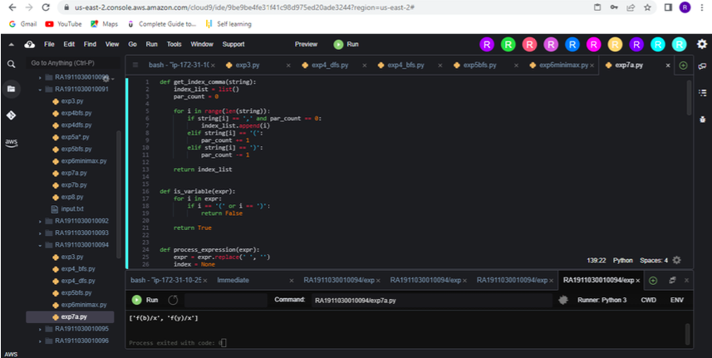

**PROCEDURE for Resolution:**

Resolution is used, if there are various statements are given, and we need to prove a conclusion of those statements. Unification is a key concept in proofs by resolutions. Resolution is a single inference rule which can efficiently operate on the conjunctive normal form or clausal form.

1. Conversion of facts into first-order logic.
2. Convert FOL statements into CNF
3. Negate the statement which needs to prove (proof by contradiction)
4. 4) Draw resolution graph (unification).

# CODE:

import copy import time class Parameter:

variable_count = 1

def init (self, name=None): if name:

self.type = "Constant" self.name = name else:

self.type = "Variable"

self.name = "v" + str(Parameter.variable_count)

Parameter.variable_count += 1

def isConstant(self):

return self.type == "Constant"

def unify(self, type_, name): self.type = type_ self.name = name

def eq (self, other):

return self.name == other.name

def str (self): return self.name

class Predicate: def

init (self, name, params): self.name = name self.params = params

def eq (self, other):

return self.name == other.name and all(a == b for a, b in zip(self.params, other.params))

def str (self):

return self.name + "(" + ",".join(str(x) for x in self.params) + ")"

def getNegatedPredicate(self):

return Predicate(negatePredicate(self.name), self.params)

class Sentence: sentence_count = 0

def init (self, string):

self.sentence_index = Sentence.sentence_count Sentence.sentence_count += 1

self.predicates = [] self.variable_map = {}

local = {}

for predicate in string.split("|"):

name = predicate[:predicate.find("(")] params = []

for param in predicate[predicate.find("(") + 1: predicate.find(")")].split(","): if param[0].islower():

if param not in local: # Variable local[param] = Parameter()

self.variable_map[local[param].name] =

local[param] new_param = local[param] else:

new_param = Parameter(param) self.variable_map[param] = new_param

params.append(new_param) self.predicates.append(Predicate(name, params))

def getPredicates(self):

return [predicate.name for predicate in self.predicates]

def findPredicates(self, name):

return [predicate for predicate in self.predicates if predicate.name == name]

def removePredicate(self, predicate): self.predicates.remove(predicate)

for key, val in self.variable_map.items():

if not val:

self.variable_map.pop(key)

def containsVariable(self):

return any(not param.isConstant() for param in self.variable_map.values())

def eq (self, other):

if len(self.predicates) == 1 and self.predicates[0] == other: return True

return False

def str (self):

return "".join([str(predicate) for predicate in self.predicates])

class KB: def init (self, inputSentences):

self.inputSentences = [x.replace(" ", "") for x in inputSentences] self.sentences = []

self.sentence_map = {}

def prepareKB(self): self.convertSentencesToCNF() for

sentence_string in self.inputSentences:

sentence = Sentence(sentence_string) for predicate in sentence.getPredicates():

self.sentence_map[predicate] = self.sentence_map.get( predicate, []) + [sentence]

def convertSentencesToCNF(self): for sentenceIdx in

range(len(self.inputSentences)): # Do negation

of the Premise and add them as literal if "=>" in self.inputSentences[sentenceIdx]:

self.inputSentences[sentenceIdx] = negateAntecedent( self.inputSentences[sentenceIdx])

def askQueries(self, queryList): results = []

for query in queryList:

negatedQuery = Sentence(negatePredicate(query.replace(" ", ""))) negatedPredicate = negatedQuery.predicates[0] prev_sentence_map = copy.deepcopy(self.sentence_map) self.sentence_map[negatedPredicate.name] = self.sentence_map.get(

negatedPredicate.name, []) + [negatedQuery] self.timeLimit = time.time() + 40

try:

result = self.resolve([negatedPredicate], [

False]*(len(self.inputSentences) + 1)) except: result = False

result:

self.sentence_map = prev_sentence_map if

else:

results.append("TRUE") results.append("FALSE")

return results

def resolve(self, queryStack, visited, depth=0): if time.time() > self.timeLimit:

raise Exception if queryStack:

query = queryStack.pop(-1) negatedQuery =

query.getNegatedPredicate() queryPredicateName = negatedQuery.name

if queryPredicateName not in self.sentence_map: return False else:

queryPredicate = negatedQuery for kb_sentence in self.sentence_map[queryPredicateName]: if not visited[kb_sentence.sentence_index]:

for kbPredicate in kb_sentence.findPredicates(queryPredicateName):

canUnify, substitution = performUnification( copy.deepcopy(queryPredicate),

copy.deepcopy(kbPredicate))

if

canUnify:

newSentence = copy.deepcopy(kb_sentence)

newSentence.removePredicate(kbPredicate) newQueryStack = copy.deepcopy(queryStack)

if

substitution:

for old, new in substitution.items(): if old in

newSentence.variable_map: parameter = newSentence.variable_map[ old] newSentence.variable_map. pop(old)

parameter.unify(

"Variable" if new[0].islower() else "Constant",

new) newSentence.variable_map[new] = parameter

for predicate in newQueryStack: for index, param in

enumerate(predicate.params): if

param.name in substitution: new = substitution[param.name]

predicate.params[index].unify(

"Variable" if new[0].islower() else "Constant",

new)

for predicate in newSentence.predicates: newQueryStack.append(predicate)

new_visited = copy.deepcopy(visited) if kb_sentence.containsVariable() and len(kb_sentence.predicates) > 1:

new_visited[kb_sentence.sentence_index] = True

if self.resolve(newQueryStack, new_visited, depth + 1):

return True

return False return True

def performUnification(queryPredicate, kbPredicate): substitution = {} if

queryPredicate == kbPredicate:

return True, {} else: for query, kb in zip(queryPredicate.params, kbPredicate.params): if query == kb: continue if kb.isConstant():

if not query.isConstant():

if query.name not in substitution: substitution[query.name] =

kb.name elif substitution[query.name] != kb.name: return False, {}

query.unify("Constant", kb.name)

else:

return False, {} else:

if not query.isConstant():

if kb.name not in substitution: substitution[kb.name] = query.name elif substitution[kb.name] != query.name: return False, {}

kb.unify("Variable", query.name) else: if kb.name not in substitution:

substitution[kb.name] =

query.name elif substitution[kb.name] != query.name:

return False, {} return True, substitution

for predicate in antecedent.split("&"): premise.append(negatePredicate(predicate))

premise.append(sentence[sentence.find("=>") + 2:]) return "|".join(premise)

def getInput(filename): with open(filename, "r") as file:

noOfQueries = int(file.readline().strip()) inputQueries = [file.readline().strip() for _ in

range(noOfQueries)] noOfSentences = int(file.readline().strip()) inputSentences = [file.readline().strip()

for _ in range(noOfSentences)] return inputQueries, inputSentences

def printOutput(filename, results): print(results) with open(filename, "w") as file:

for line in results: file.write(line) file.write("\n")

file.close()

if name == ' main ': inputQueries_, inputSentences_ =

getInput('/home/ubuntu/environment/RA1911030010091/input.txt') knowledgeBase = KB(inputSentences_) knowledgeBase.prepareKB()

results_ = knowledgeBase.askQueries(inputQueries_) printOutput("output.txt", results_)

# INPUT.txt code:

2

Friends(Alice,Bob,Charlie,Diana) Friends(Diana,Charlie,Bob,Alice) 2

Friends(a,b,c,d)

NotFriends(a,b,c,d)

**Screenshot:**

**RESULT:** Hence, Unification and Resolution were implemented.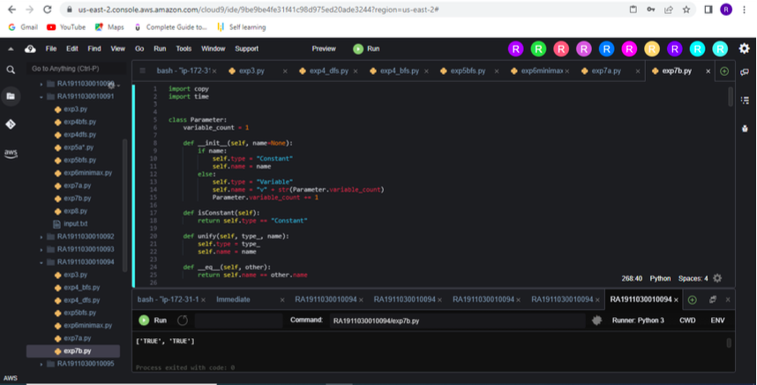

# LAB 8 - Implementation of knowledge representation schemes - use cases

**AIM:** To implement knowledge representation schemes.

# ALGORTIHM:

* + Create a knowledge base with identification rules.
  + Create a question-and-answer knowledge.
  + Ask question to user
  + Use the inputs to the database
  + If an animal is found print the guess.

# CODE:

/* animal.pl animal identification game.

start with ?- go. */ go :- hypothesize(Animal), write('I guess that the animal is: '), write(Animal),

nl, undo.

/* hypotheses to be tested */ hypothesize(cheetah) :- cheetah, !. hypothesize(tiger) :- tiger, !. hypothesize(giraffe) :- giraffe, !. hypothesize(zebra) :- zebra, !. hypothesize(ostrich) :- ostrich, !. hypothesize(penguin) :- penguin, !. hypothesize(albatross) :- albatross, !. hypothesize(unknown). /* no diagnosis */

/* animal identification rules */ cheetah :- mammal,

carnivore,

verify(has_tawny_color), verify(has_dark_spots).

tiger :- mammal, carnivore,

verify(has_tawny_color), verify(has_black_stripes). giraffe

:- ungulate, verify(has_long_neck), verify(has_long_legs).

zebra :- ungulate, verify(has_black_stripes).

ostrich :- bird, verify(does_not_fly), verify(has_long_neck). penguin :- bird, verify(does_not_fly), verify(swims), verify(is_black_and_white). albatross :- bird,

verify(appears_in_story_Ancient_Mariner), verify(flys_well).

/* classification rules */ mammal :- verify(has_hair),

!. mammal :- verify(gives_milk). bird :- verify(has_feathers), !.

bird :- verify(flys), verify(lays_eggs). carnivore :- verify(eats_meat), !. carnivore :- verify(has_pointed_teeth), verify(has_forward_eyes).

verify(has_claws),

Ungulate

:- mammal,

verify(has_hooves), !. ungulate :- mammal,

verify(chews_cud).

/* how to ask questions */ ask(Question) :-

write('Does the animal have the following attribute: '), write(Question), write('? '), read(Response),

nl,

( (Response == yes ; Response == y)

->

assert(yes(Question)) ; assert(no(Question)), fail).

:- dynamic yes/1,no/1.

/* How to verify something */ verify(S) :-

(yes(S)

->

true ;

(no(S)

-> fail ; ask(S))).

/* undo all yes/no assertions

*/ undo :- retract(yes(_)),fail. undo :- retract(no(_)),fail. undo.

# OUTPUT:Image

**RESULT:** Hence, knowledge representation schemes was implemented.

# LAB 9 - Implementation of uncertain methods for an application

**AIM:** To implement uncertain methods for Monty Hall problem.

# Problem Statement:

The Monty Hall problem is a counter-intuitive statistics puzzle:

* + There are 3 doors, behind which are two goats and a car.
  + You pick a door (call it door A). You’re hoping for the car of course.
  + Monty Hall, the game show host, examines the other doors (B & C) and opens one with a goat. (If both doors have goats, he picks randomly.)

**CODE:**

import matplotlib.pyplot as plt

import seaborn; seaborn.set_style('whitegrid') import numpy from

pomegranate import * numpy.random.seed(0) numpy.set_printoptions(suppress=True)

guest = DiscreteDistribution({'A': 1./3, 'B': 1./3, 'C': 1./3})

prize = DiscreteDistribution({'A': 1./3, 'B': 1./3, 'C': 1./3}) monty = ConditionalProbabilityTable(

[[ 'A', 'A', 'A', 0.0 ],

[ 'A', 'A', 'B', 0.5

], [ 'A', 'A', 'C',

0.5 ], [ 'A', 'B', 'A', 0.0 ],

[ 'A', 'B', 'B', 0.0

], [ 'A', 'B', 'C', 1.0 ],

[ 'A', 'C', 'A', 0.0 ],

[ 'A', 'C', 'B', 1.0

], [ 'A', 'C', 'C', 0.0 ],

[ 'B', 'A', 'A', 0.0 ],

[ 'B', 'A', 'B', 0.0

], [ 'B', 'A', 'C',

1.0 ], [ 'B', 'B', 'A', 0.5 ],

[ 'B', 'B', 'B', 0.0

], [ 'B', 'B', 'C', 0.5 ],

[ 'B', 'C', 'A', 1.0 ],

[ 'B', 'C', 'B', 0.0

], [ 'B', 'C', 'C', 0.0 ],

[ 'C', 'A', 'A', 0.0 ],

[ 'C', 'A', 'B', 1.0

], [ 'C', 'A', 'C',

0.0 ], [ 'C', 'B', 'A', 1.0 ],

[ 'C', 'B', 'B', 0.0

], [ 'C', 'B', 'C', 0.0 ],

[ 'C', 'C', 'A', 0.5 ],

[ 'C', 'C', 'B', 0.5 ],

[ 'C', 'C', 'C', 0.0 ]], [guest,

prize]) s1 = State(guest, name="guest") s2 = State(prize, name="prize")

s3 = State(monty, name="monty")

# Create the Bayesian network object with a useful name model = BayesianNetwork("Monty Hall Problem") model.add_states(s1, s2, s3)

model.add_edge(s1, s3) model.add_edge(s2, s3) model.bake() model.probability([['A', 'B', 'C']])

model.probability([['A', 'B', 'C']]) print(model.predict_proba({})) print(model.predict_proba([[None, None, None]])) print(model.predict_proba([['A', None, None]])) print(model.predict_proba([{'guest': 'A', 'monty': 'B'}]))

# SCREENSHOTS

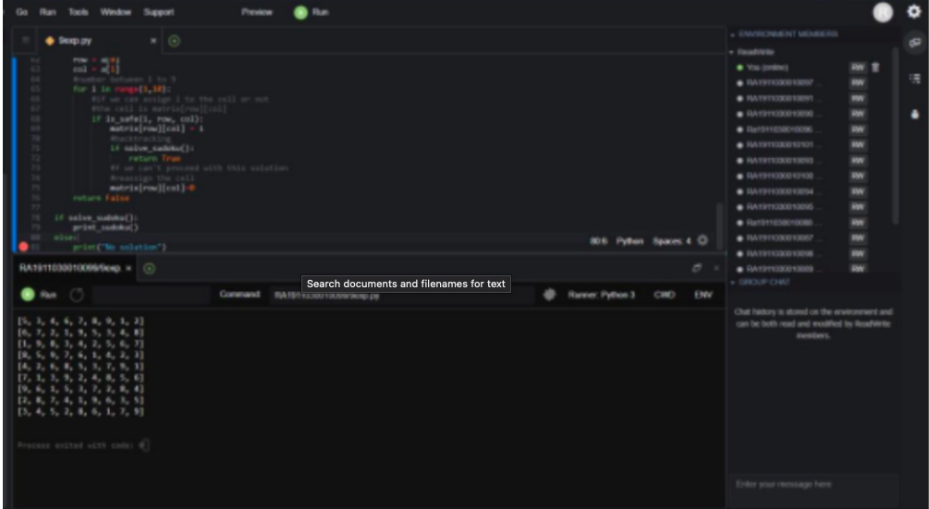

**RESULT:** Hence, the uncertain method for an application was implemented.

**LAB 10 -Implementation of Block world Problem AIM:** To implement block world problem.

# Problem Statement:

The blocks world is a planning domain in artificial intelligence. The algorithm is similar to a set of wooden blocks of various shapes and colors sitting on a table. The goal is to build one or more vertical stacks of blocks. Only one block may be moved at a time: it may either be placed on the table or placed atop another block. Because of this, any blocks that are, at a given time, under another block cannot be moved. Moreover, some kinds of blocks cannot have other blocks stacked on top of them

# CODE:

class PREDICATE:

def str (self): pass def

repr (self): pass def

eq (self, other) : pass def

hash (self):

pass def get_action(self, world_state):

pass

class Operation: def str (self):

pass def

repr (self): pass def

eq (self, other) : pass def precondition(self):

pass def delete(self): pass def

add(self): pass

class ON(PREDICATE):

def init (self, X, Y):

self.X = X self.Y = Y

def str (self):

return "ON({X},{Y})".format(X=self.X,Y=self.Y)

def repr (self):

return self. str ()

def eq (self, other) :

return self. dict == other. dict and self. class == other. class

def hash (self):

return hash(str(self))

def get_action(self, world_state):

return StackOp(self.X,self.Y) class ONTABLE(PREDICATE):

def init (self, X):

self.X = X

def str (self):

return "ONTABLE({X})".format(X=self.X)

def repr (self):

return self. str ()

def eq (self, other) :

return self. dict == other. dict and self. class == other. class

def hash (self):

return hash(str(self))

def get_action(self, world_state): return PutdownOp(self.X)

class CLEAR(PREDICATE):

def init (self, X):

self.X = X

def str (self):

return "CLEAR({X})".format(X=self.X) self.X = X

def repr (self):

return self. str ()

def eq (self, other) :

return self. dict == other. dict and self. class == other. class

def hash (self):

return hash(str(self)) def get_action(self, world_state): for predicate in world_state: #If Block is on another block, unstack if

isinstance(predicate,ON) and predicate.Y==self.X:

return UnstackOp(predicate.X, predicate.Y) return None

class HOLDING(PREDICATE):

def init (self, X):

self.X = X

def str (self):

return "HOLDING({X})".format(X=self.X)

def repr (self):

return self. str ()

def eq (self, other) :

return self. dict == other. dict and self. class == other. class

def hash (self):

return hash(str(self))

def get_action(self, world_state):

X = self.X

#If block is on table, pick up if ONTABLE(X) in world_state:

return PickupOp(X)

#If block is on another block, unstack else: for predicate in world_state:

if isinstance(predicate,ON) and predicate.X==X: return UnstackOp(X,predicate.Y)

class ARMEMPTY(PREDICATE):

def init (self):

pass

def str (self):

return "ARMEMPTY"

def repr (self):

return self. str ()

def eq (self, other) :

return self. dict == other. dict and self. class == other. class

def hash (self):

return hash(str(self))

def get_action(self, world_state=[]): for predicate in world_state:

if isinstance(predicate,HOLDING): return PutdownOp(predicate.X) return None

class StackOp(Operation): def init (self, X, Y):

self.X = X self.Y = Y

def str (self):

return "STACK({X},{Y})".format(X=self.X,Y=self.Y)

def repr (self):

return self. str ()

def eq (self, other) :

return self. dict == other. dict and self. class == other. class

def precondition(self):

return [ CLEAR(self.Y) , HOLDING(self.X) ]

def delete(self):

return [ CLEAR(self.Y) , HOLDING(self.X) ]

def add(self):

return [ ARMEMPTY() , ON(self.X,self.Y) ] class UnstackOp(Operation):

def init (self, X, Y):

self.X = X self.Y = Y

def str (self):

return "UNSTACK({X},{Y})".format(X=self.X,Y=self.Y)

def repr (self):

return self. str ()

def eq (self, other) :

return self. dict == other. dict and self. class == other. class

def precondition(self):

return [ ARMEMPTY() , ON(self.X,self.Y) , CLEAR(self.X) ]

def delete(self):

return [ ARMEMPTY() , ON(self.X,self.Y) ]

def add(self):

return [ CLEAR(self.Y) , HOLDING(self.X) ] class PickupOp(Operation):

def init (self, X):

self.X = X

def str (self):

return "PICKUP({X})".format(X=self.X)

def repr (self):

return self. str ()

def eq (self, other) :

return self. dict == other. dict and self. class == other. class

def precondition(self):

return [ CLEAR(self.X) , ONTABLE(self.X) , ARMEMPTY() ]

def delete(self):

return [ ARMEMPTY() , ONTABLE(self.X) ]

def add(self):

return [ HOLDING(self.X) ] class PutdownOp(Operation):

def init (self, X):

self.X = X

def str (self):

return "PUTDOWN({X})".format(X=self.X)

def repr (self): return self. str ()

def eq (self, other) :

return self. dict

== other. dict

and self. class

== other. class

def

precondition(self): return [ HOLDING(self.X) ]

def delete(self):

return [ HOLDING(self.X) ]

def add(self):

return [ ARMEMPTY() , ONTABLE(self.X) ]

def isPredicate(obj):

predicates = [ON, ONTABLE, CLEAR, HOLDING,

ARMEMPTY] for predicate in predicates: if isinstance(obj,predicate):

return True return False

def isOperation(obj):

operations = [StackOp, UnstackOp, PickupOp, PutdownOp] for operation in operations: if isinstance(obj,operation):

return True return False

def arm_status(world_state):

for predicate in world_state: if isinstance(predicate, HOLDING):

return predicate return ARMEMPTY()

class GoalStackPlanner:

def init (self, initial_state, goal_state): self.initial_state = initial_state self.goal_state = goal_state

def get_steps(self):

#Store Steps steps = []

#Program Stack stack = []

#World State/Knowledge Base world_state = self.initial_state.copy()

#Initially push the goal_state as compound goal onto the stack stack.append(self.goal_state.copy())

#Repeat until the stack is empty while len(stack)!=0:

#Get the top of the stack stack_top = stack[-1]

#If Stack Top is Compound Goal, push its unsatisfied goals onto stack if type(stack_top) is list:

compound_goal = stack.pop() for goal in compound_goal: if goal not in world_state:

stack.append(goal)

#If Stack Top is an action elif isOperation(stack_top):

#Peek the operation operation = stack[-1]

all_preconditions_satisfied = True

#Check if any precondition is unsatisfied and push it onto program stack for predicate in operation.delete(): if predicate not in world_state: all_preconditions_satisfied = False stack.append(predicate)

#If all preconditions are satisfied, pop operation from stack and execute it if all_preconditions_satisfied:

stack.pop() steps.append(operation)

for predicate in operation.delete(): world_state.remove(predicate) for predicate in operation.add(): world_state.append(predicate)

#If Stack Top is a single satisfied goal elif stack_top in world_state:

stack.pop()

#If Stack Top is a single unsatisfied goal else:

unsatisfied_goal = stack.pop()

#Replace Unsatisfied Goal with an action that can complete it action = unsatisfied_goal.get_action(world_state) stack.append(action)

#Push Precondition on the stack for predicate in action.precondition(): if predicate not in world_state:

stack.append(predicate) return steps if name == " main ":

initial_state = [ ON('B','A'),

ON('C','B'),

ONTABLE('A'),ONTABLE('D'),

CLEAR('C'),CLEAR('D'), ARMEMPTY()

]

goal_state = [ ON('B','D'),ON('C','A'), ONTABLE('D'),ONTABLE('A'),

CLEAR('B'),CLEAR('C'), ARMEMPTY()

]

goal_stack = GoalStackPlanner(initial_state=initial_state, goal_state=goal_state) steps = goal_stack.get_steps() print(steps)

# OUTPUT:

[UNSTACK(C,B), PUTDOWN(C), UNSTACK(B,A), PUTDOWN(B), PICKUP(C), STACK(C,A), PICKUP(B), STACK(B,D)]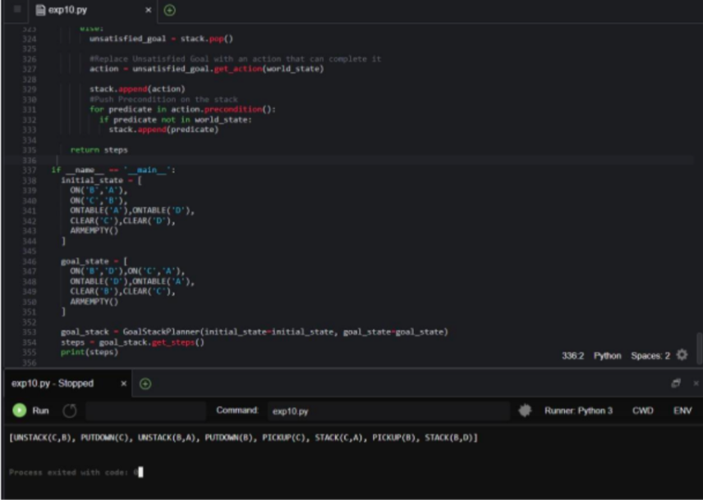

# RESULT:

Hence, Block world problem was implemented.